Revision and Redo job creation (Important)
After we create invoice for one job e.g. 1503/00008, we cannot trace back the job in the Job List.
Therefore we cannot create a revision job or redo job.
Currently, only Job Order which haven’t been invoiced (i.e. active job) can be seen in the Job List. Search of the old job not appeared in the list.

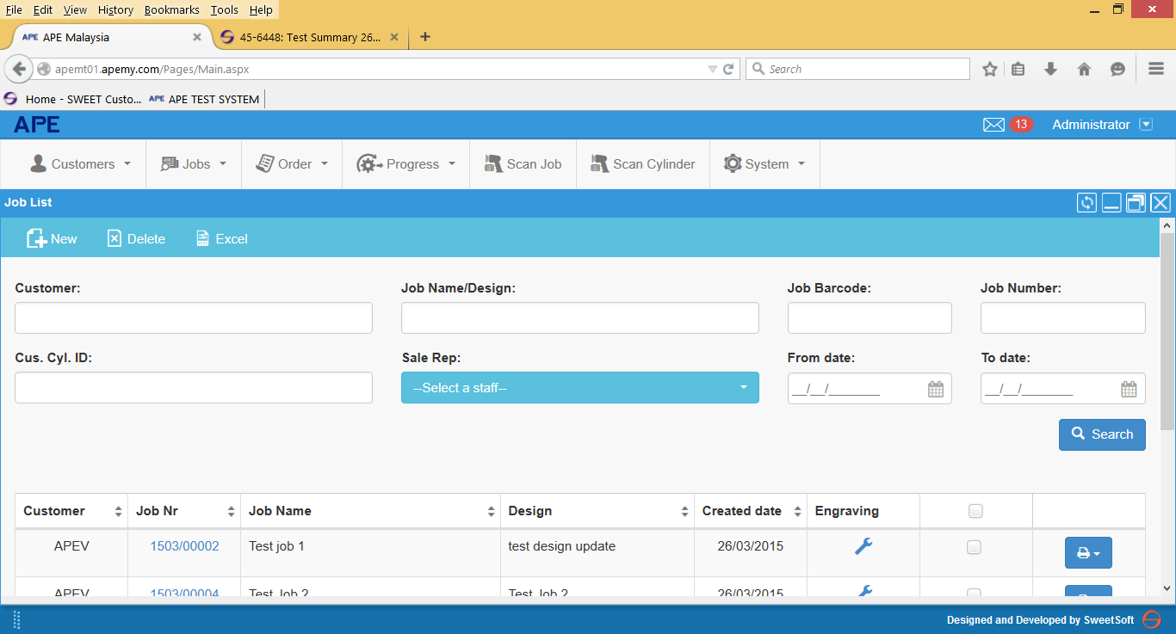

Protocol selection option.
I have added additional protocol in the process type reference table i.e. CNC, Digilas and CR. However the new values do not appeared in the protocol list selection when creating a new job.
Do we have a separate table for protocol list?
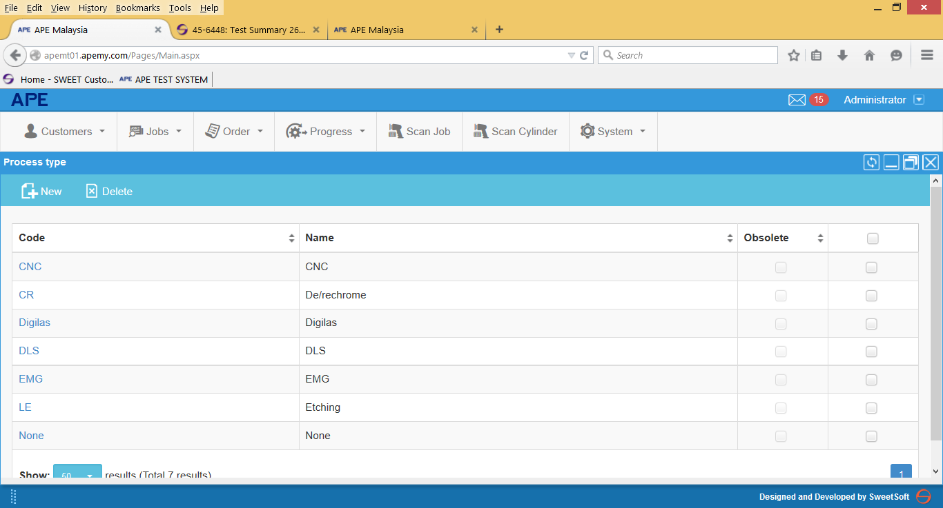

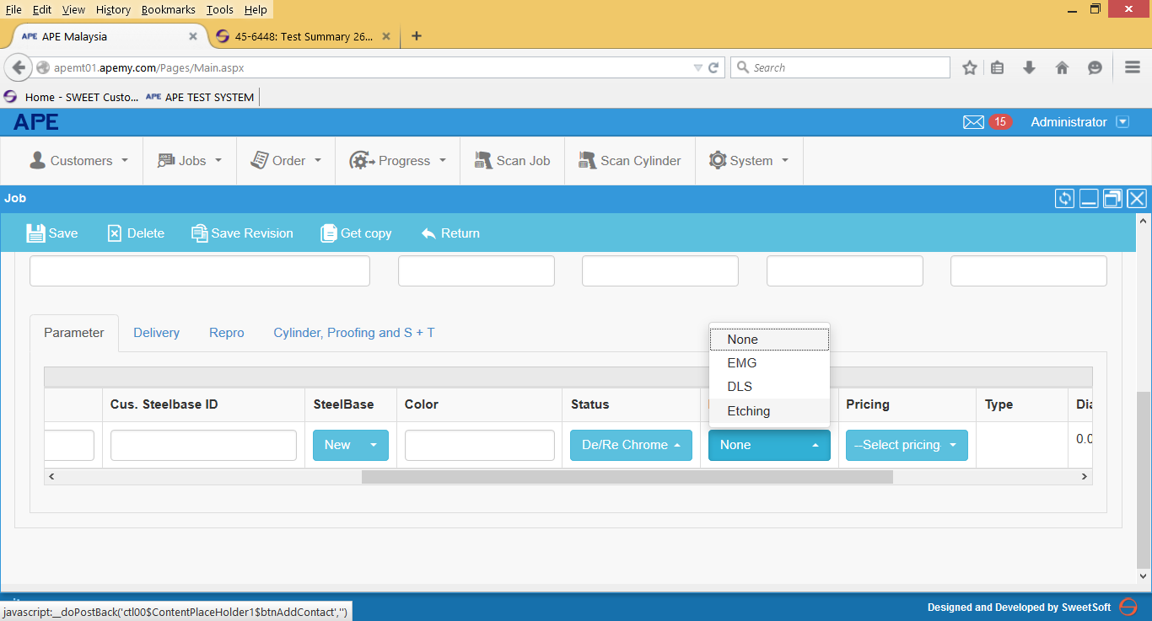

Additional Issue for OC/ DO and Invoice.- Additional remark after Test summary document on 26.03.2015.
Order Confirmation Input Screen:
- One remark column is enough. Please remove Remark (screen) column
- Payment terms and delivery terms – Automatic from Customer Master.
- Is there an option to select pricing name and copy into the description column? Currently, we have to re-type the pricing name in the decsription column.

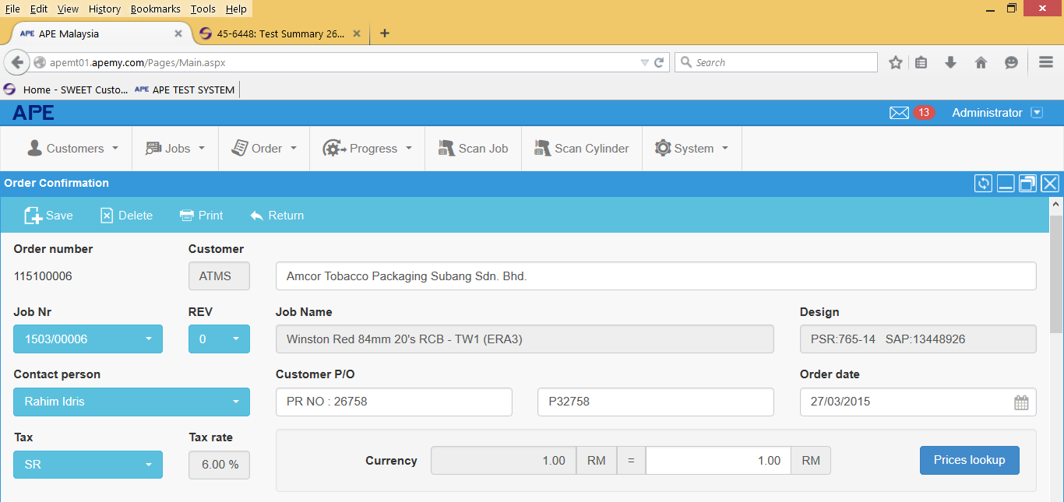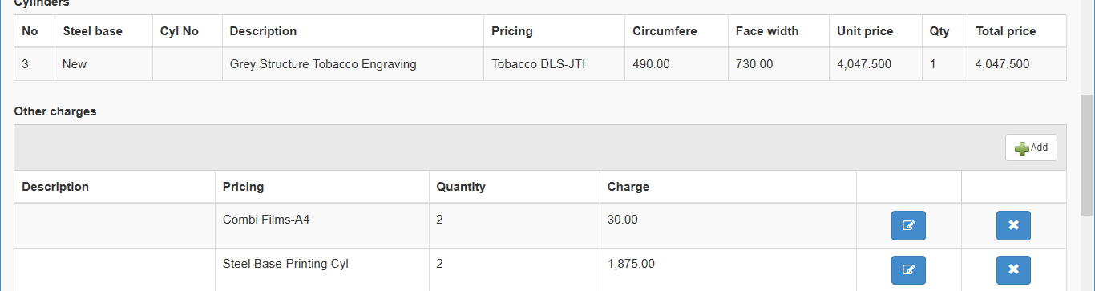
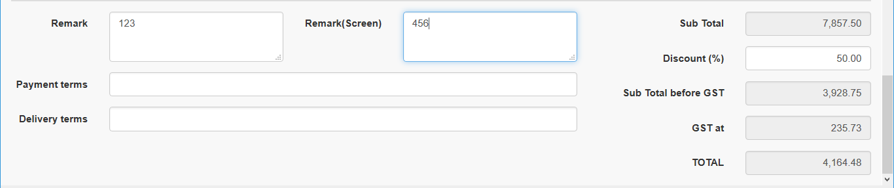

Order Confirmation Printout – Additonal remark
- All colour sequence must be shown in the Order Confirmation and Invoice Printout. This is very important since we need to know total no. of colour in one Job. Only in DO printout we do not need all colour sequence.
Is the setting comes from cylinder status reference table?
- Alignment for payment and delivery terms issue and Automatic value from Cust. Master.
- Job Name: Make it printed in one line only
- Add “Attn to” column before your reference. The value is from Job Order contact person column.
- Rename “Discount” to “Discount at [value] %” . The Value comes from Discount value in OC entry screen.
- Remark column . Please align the input text
- Remove the line Before Asia Pacific Engraver (M) Sdn Bhd.
- Add username for OC creator
- Add additional Acknowledgement field.

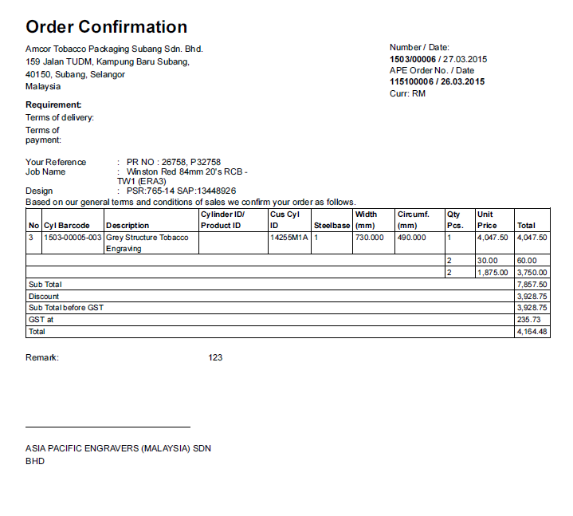
Kindly acknowledge receipt of this order confirmation. Thank you

Name:
Date:
Remove this line

Add username for OC creator.

Delivery Order – Additional remark
- Total Cylinder delivered column not in the right place.
- Remarks column not appeared in the print out,
- Add customer acknowledgement details
- Add DO creator name in the printout.

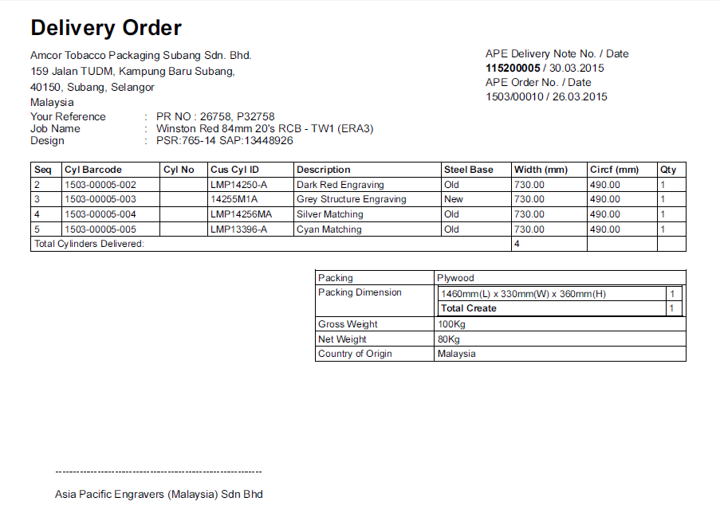
Goods received in good condition

Company Rubber Stamp:
Name:
Designation:
Date:
Add username for OC creator.

Remove this line

Delivery Note for Transporter.
- Job Name – Make it appeared in one line only.

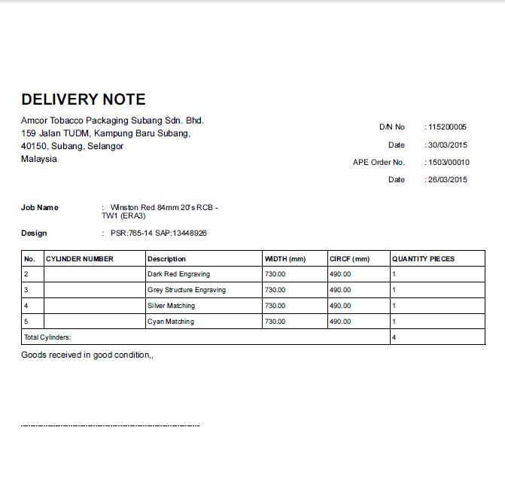

Invoice Print out – Additional remark
- All colour sequence including matching/existing / common /de-rechrome must appeared in the printout.
Is the setting comes from cylinder status reference table?

